14. ReactJS-HOL

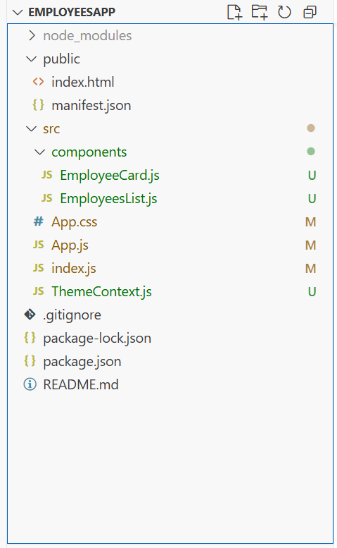

EmployeeCard.js
import React, { useContext } from "react";
import ThemeContext from "../ThemeContext";

function EmployeeCard({ employee }) {
const theme = useContext(ThemeContext);

return (
<div className={`employee-card ${theme}`}>
<h3>{employee.name}</h3>
<p>{employee.role}</p>
<button className={`btn-${theme}`}>View Profile</button>
</div>
);
}

export default EmployeeCard;

EmployeesList.js
import React from "react";
import EmployeeCard from "./EmployeeCard";

function EmployeesList() {
const employees = [
{ id: 1, name: "Alice", role: "Developer" },
{ id: 2, name: "Bob", role: "Designer" },
{ id: 3, name: "Charlie", role: "Manager" }
];

return (
<div>
<h2>Employees</h2>
{employees.map((emp) => (
<EmployeeCard key={emp.id} employee={emp} />
))}
</div>
);
}

export default EmployeesList;

App.js
import React, { useState } from "react";
import ThemeContext from "./ThemeContext";
import EmployeesList from "./components/EmployeesList";

function App() {
const [theme, setTheme] = useState("light");

const toggleTheme = () => {
setTheme(theme === "light" ? "dark" : "light");
};

return (
<ThemeContext.Provider value={theme}>
<div className={`employee-list ${theme}`}>
<h1>Employee Management App</h1>
<button onClick={toggleTheme}>
Switch to {theme === "light" ? "Dark" : "Light"} Theme
</button>
<EmployeesList />
</div>
</ThemeContext.Provider>
);
}

export default App;

App.css
/* App.css */

body {
margin: 0;
font-family: 'Segoe UI', Tahoma, Geneva, Verdana, sans-serif;
background-color: #f5f5f5;
}

.container {
max-width: 1000px;
margin: auto;
padding: 20px;
}

h1 {
text-align: center;
font-size: 32px;
color: #333;
margin-bottom: 20px;
}

.theme-toggle-button {
display: block;
margin: 0 auto 30px auto;
padding: 10px 16px;
background-color: #007bff;
color: white;
border: none;
border-radius: 6px;
font-size: 14px;
cursor: pointer;
transition: background-color 0.3s;
}

.theme-toggle-button:hover {
background-color: #0056b3;
}

.employees-section h2 {
color: #444;
font-size: 24px;
margin-bottom: 20px;
}

/* Flex layout for employee cards */
.employee-list {
display: flex;
flex-wrap: wrap;
gap: 20px;
justify-content: center;
}

/* Employee Card Styling */
.employee-card {
background-color: white;
border-radius: 10px;
padding: 20px;
width: 240px;
box-shadow: 0 4px 10px rgba(0, 0, 0, 0.1);
transition: transform 0.2s ease, box-shadow 0.2s ease;
}

.employee-card:hover {
transform: translateY(-5px);
box-shadow: 0 6px 16px rgba(0, 0, 0, 0.2);
}

.employee-card h3 {
margin: 0;
font-size: 20px;
color: #222;
}

.employee-card p {
margin: 5px 0 15px;
color: #666;
}

/* View Profile Button */
.employee-card button {
border-radius: 6px;
cursor: pointer;
transition: background-color 0.2s;
}

.employee-card button:hover {
background-color: #218838;
}

ThemeContext.js
import React from "react";

// Create context with default theme 'light'
const ThemeContext = React.createContext('light');

export default ThemeContext;

